Software Used in this Lab

In this lab, you will use [IBM Db2 Database](https://www.ibm.com/products/db2-database). Db2 is a Relational Database Management System (RDBMS) from IBM, designed to store, analyze and retrieve the data efficiently.

To complete this lab you will utilize a Db2 database service on IBM Cloud. If you did not already complete this lab task earlier in this module, you will not yet have access to Db2 on IBM Cloud, and you will need to follow the lab below first:

* [Hands-on Lab : Sign up for IBM Cloud, Create Db2 service instance and Get started with the Db2 console](https://cf-courses-data.s3.us.cloud-object-storage.appdomain.cloud/IBMDeveloperSkillsNetwork-DB0201EN-SkillsNetwork/labs/Labs_Coursera_V5/labs/Lab%20-%20Sign%20up%20for%20IBM%20Cloud%20-%20Create%20Db2%20service%20instance%20-%20Get%20started%20with%20the%20Db2%20console/instructional-labs.md.html)

Database Used in this Lab

The database used in this lab is an internal database. You will be working on a sample HR database. This HR database schema consists of 5 tables called **EMPLOYEES**, **JOB_HISTORY**, **JOBS**, **DEPARTMENTS** and **LOCATIONS**. Each table has a few rows of sample data. The following diagram shows the tables for the HR database:

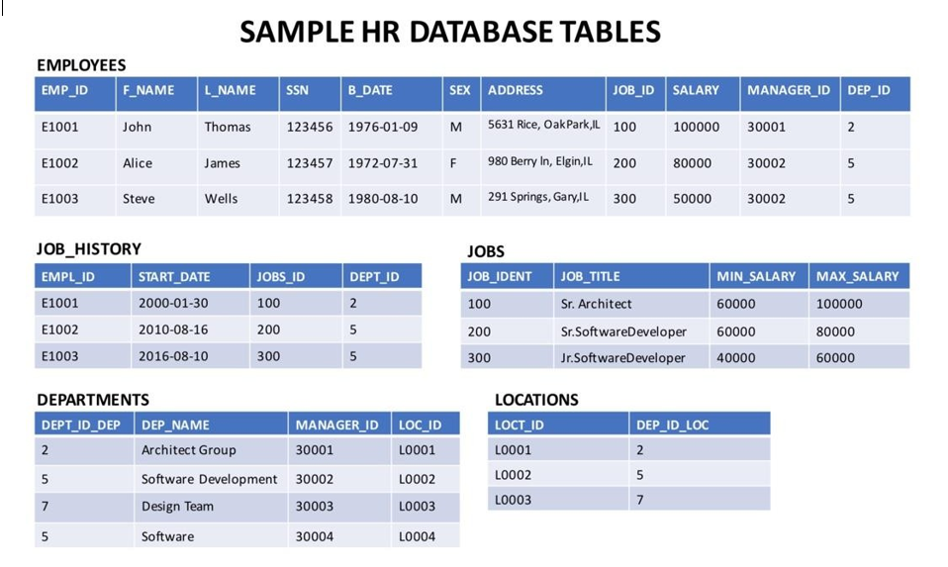

**NOTE:** This lab requires you to have all 5 of these tables of the HR database populated with sample data on Db2. If you don't have the tables above populated with sample data on Db2, please go through the lab below first:

* [Hands-on Lab : Create tables using SQL scripts and Load data into tables](https://cf-courses-data.s3.us.cloud-object-storage.appdomain.cloud/IBMDeveloperSkillsNetwork-DB0201EN-SkillsNetwork/labs/Labs_Coursera_V5/labs/Lab%20-%20Create%20tables%20using%20SQL%20scripts%20and%20Load%20data%20into%20tables/instructional-labs.md.html)

Objectives

After completing this lab, you will be able to:

* Create a View and show a selection of data for a given table
* Update a View to combine two or more tables in meaningful ways
* Drop a created View

Instructions

When you approach the exercises in this lab, follow the instructions to run the queries on Db2:

* Go to the [Resource List](https://cloud.ibm.com/resources?utm_medium=Email&utm_source=Nurture&utm_content=000026UJ&utm_term=10006555&utm_id=SkillsNetwork-Courses-IBMDeveloperSkillsNetwork-DB0201EN-SkillsNetwork-20127838) of IBM Cloud by logging in where you can find the Db2 service instance that you created in a previous lab under **Services** section. Click on the **Db2-xx service**. Next, open the Db2 Console by clicking on **Open Console** button. Click on the 3-bar menu icon in the top left corner and go to the **Run SQL** page. The Run SQL tool enables you to run SQL statements.
  + If needed, follow [Hands-on Lab : Sign up for IBM Cloud, Create Db2 service instance and Get started with the Db2 console](https://cf-courses-data.s3.us.cloud-object-storage.appdomain.cloud/IBMDeveloperSkillsNetwork-DB0201EN-SkillsNetwork/labs/Labs_Coursera_V5/labs/Lab%20-%20Sign%20up%20for%20IBM%20Cloud%20-%20Create%20Db2%20service%20instance%20-%20Get%20started%20with%20the%20Db2%20console/instructional-labs.md.html)

Exercise 1: Create a View

In this exercise, you will create a View and show a selection of data for a given table.

1. Let's create a view called **EMPSALARY** to display salary along with some basic sensitive data of employees from the HR database. To create the **EMPSALARY** view from the **EMPLOYEES** table, copy the code below and paste it to the textbox of the **Run SQL** page. Click **Run all**.
2. **CREATE** **VIEW** EMPSALARY **AS**
3. **SELECT** EMP_ID, F_NAME, L_NAME, B_DATE, SEX, SALARY
4. **FROM** EMPLOYEES;

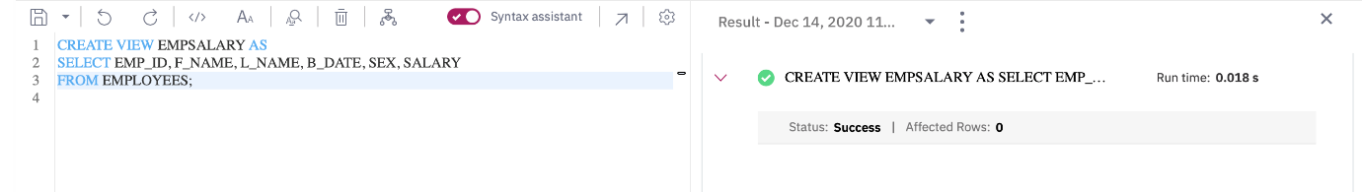

1. Using SELECT, query the **EMPSALARY** view to retrieve all the records. Copy the code below and paste it to the textbox of the **Run SQL** page. Click **Run all**.
2. **SELECT** * **FROM** EMPSALARY;

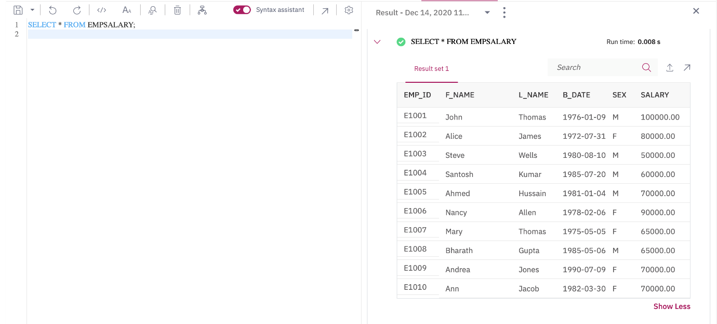

Exercise 2: Update a View

In this exercise, you will update a View to combine two or more tables in meaningful ways.

1. It now seems that the **EMPSALARY** view we created in exercise 1 doesn't contain enough salary information, such as max/min salary and the job title of the employees. Let's update the **EMPSALARY** view:
   * combining two tables **EMPLOYEES** and **JOBS** so that we can display our desired information from the HR database.
   * including the columns **JOB_TITLE, MIN_SALARY, MAX_SALARY** of the **JOBS** table as well as excluding the **SALARY** column of the **EMPLOYEES** table.

Copy the code below and paste it to the textbox of the **Run SQL** page. Click **Run all**.

**CREATE** **OR** REPLACE **VIEW** EMPSALARY **AS**

**SELECT** EMP_ID, F_NAME, L_NAME, B_DATE, SEX, JOB_TITLE, MIN_SALARY, MAX_SALARY

**FROM** EMPLOYEES, JOBS

**WHERE** EMPLOYEES.JOB_ID = JOBS.JOB_IDENT;

**NOTE:** Don't worry if you don't understand how to combine to two tables using implicit inner join. You will learn more about joins later on. For now, just think you are combining the data of two different tables, **EMPLOYEES** and **JOBS** by connecting their respective columns **JOB_ID** and **JOB_IDENT** since both the columns contain common unique data. You can have a look at the diagram (at the beginning of the lab) showing the tables for the HR database to observe how the **JOB_ID** and **JOB_IDENT** columns from the **EMPLOYEES** and **JOBS** tables respectively contain common unique data.

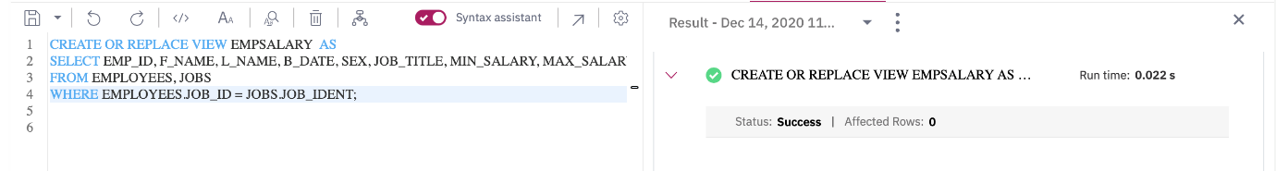

1. Using SELECT, query the updated **EMPSALARY** view to retrieve all the records. Copy the code below and paste it to the textbox of the **Run SQL** page. Click **Run all**.
2. **SELECT** * **FROM** EMPSALARY;

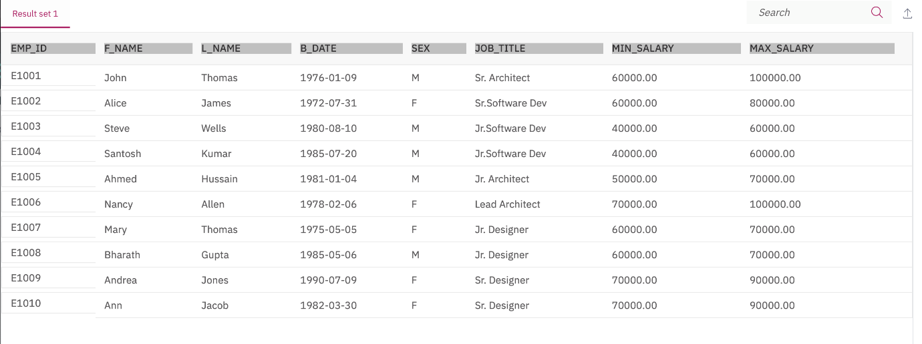

Exercise 3: Drop a View

In this exercise, you will drop a created View.

1. Let's delete the created **EMPSALARY** view. Copy the code below and paste it to the textbox of the **Run SQL** page. Click **Run all**.
2. DROP VIEW EMPSALARY;

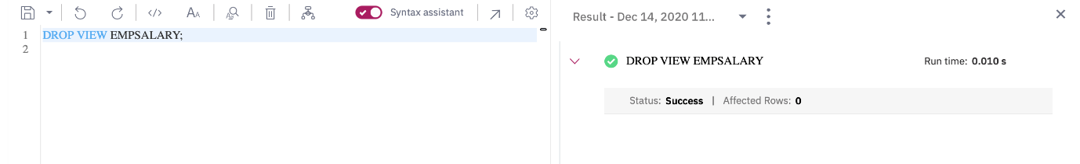

1. Using SELECT, you can verify whether the **EMPSALARY** view has been deleted or not. Copy the code below and paste it to the textbox of the **Run SQL** page. Click **Run all**.
2. **SELECT** * **FROM** EMPSALARY;

